

***Entity Framework***

**Lab Guides**

|  |  |
| --- | --- |
| Document Code | 25e-BM/HR/HDCV/FSOFT |
| Version | 1.1 |
| Effective Date | 20/11/2012 |

**Hanoi, 07/2019**

RECORD OF CHANGES

|  |  |  |  |  |  |
| --- | --- | --- | --- | --- | --- |
| No | Effective Date | Change Description | Reason | Reviewer | Approver |
|  | 01/Oct/2018 | TuTB create new | Draft |  |  |
|  |  |  |  |  |  |
|  |  |  |  |  |  |
|  |  |  |  |  |  |
|  |  |  |  |  |  |
|  |  |  |  |  |  |
|  |  |  |  |  |  |
|  |  |  |  |  |  |
|  |  |  |  |  |  |
|  |  |  |  |  |  |

Contents

Lab: Adding a New Controller 4

Objectives: 4

Prerequisites: 4

Problem Description: 4

Guidelines: 4

Step 1: Open MVC project that created in NWEB.S.L001 4

Step 2: Add new controller 4

Step 3: Select controller template 5

Step 4: Add **StudentController** 5

Step 5: Create action Index 5

Step 6: Run and check result 6

|  |  |
| --- | --- |
|  | **CODE: NWEV.S.L003**  **TYPE: SHORT**  **LOC: 120**  **DURATION: 30 MINUTES** |

# Lab: Adding a New Controller

Objectives:

* Add a new empty controller in our MVC application

Prerequisites:

* Complete lab NWEB.S.L001.

Problem Description:

Guidelines:

### Step 1: Open MVC project that created in NWEB.S.L001

### Step 2: Add new controller

In the Visual Studio, right click on the Controller folder -> select Add -> click on Controller.

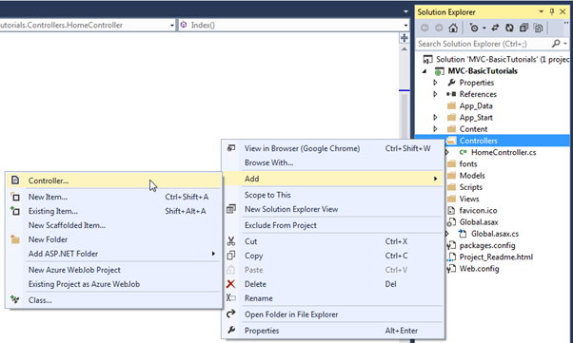

### Step 3: Select controller template

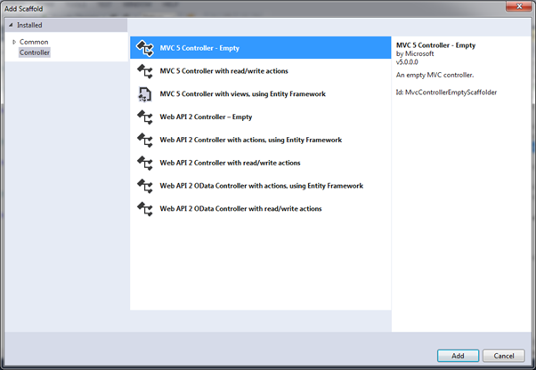

### Step 4: Add **StudentController**

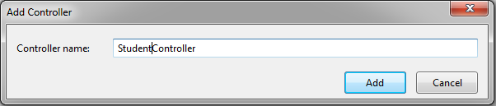

### Step 5: Create action Index

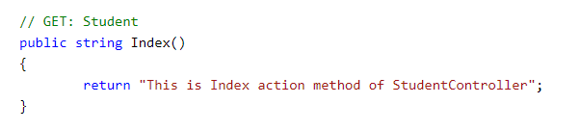

### Step 6: Run and check result

